Security Design Document

This document covers all the security features I have implemented for the case studies so far. The initial designs are in the design document and the official diagrams.

Firewall Rules
The on-premise network is protected by two pfSense firewalls. Router 1 (R1) is the outside router: it connects to the internet and holds the site-to-site VPN to AWS. Router 2 (R2) is the router on the inside. It sits behind R1 on the TRANSIT network (192.168.10.0/24) and separates the DEPT, SERVERS and MONITORING subnets. PfSense reads the rules from top to bottom and uses the first rule that matches. Anything that is not allowed by a rule is blocked by default.

Router 1 (Outside router)
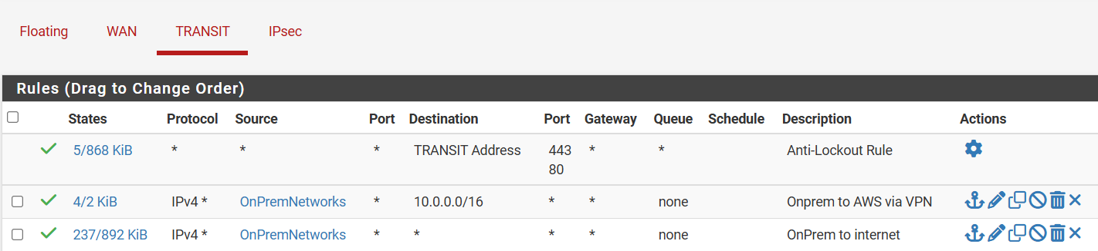
The TRANSIT interface (Router 1) is the traffic coming up from Router 2 and the internal networks.
- Anti-Lockout Rule: keeps the web interface (port 80/443) reachable so the router can always be managed.
- Onprem to AWS via VPN: so the on-premise networks can reach the AWS VPCs (10.0.0.0/16). This traffic goes through the IPsec tunnel.
- OnPrem to internet: so the on-premise networks can go out to the internet.
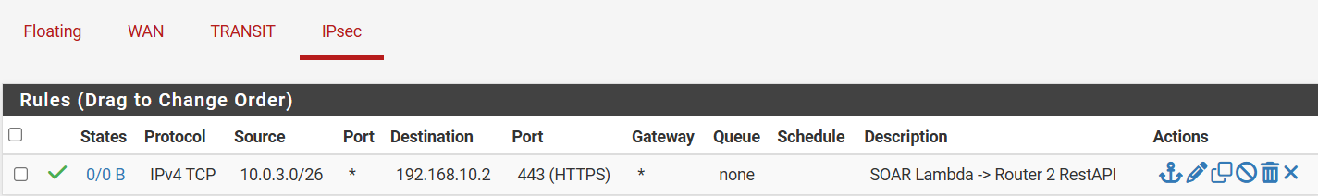
The IPsec interface rules cover the traffic coming in from AWS through the VPN.
- SOAR Lambda -> Router 2 RestAPI: only the SOAR subnet (10.0.3.0/26) is able to reach Router 2 (192.168.10.2) on HTTPS 443. Every other connection that AWS starts towards on-premise is blocked.

Router 2 (Inside router)
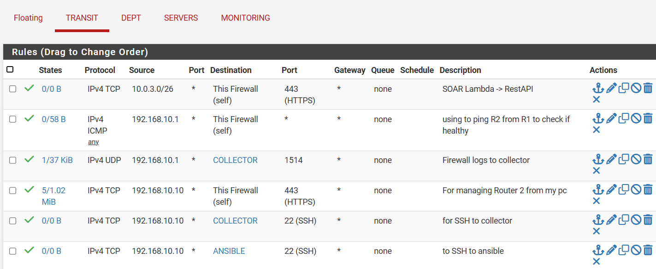
The TRANSIT interface (Router 2) covers the traffic arriving at Router 2 from the TRANSIT network (Router 1, the VPN and my personal PC).
- SOAR Lambda -> RestAPI: the SOAR Lambda (10.0.3.0/26) can call the REST API of Router 2 on 443 so it can block the attacker.
- ICMP from Router 1 (192.168.10.1): Router 1 pings Router 2 to check if the gateway is healthy. I created it at some point during the initial configuration, but I have not used it since. I will still keep it if needed for troubleshooting.
- Firewall logs to collector: Router 1 sends its firewall logs to the collector on UDP 1514.
- My PC (192.168.10.10): so that I can open the Router 2 web interface (443) and SSH (22) into the collector and the Ansible server.
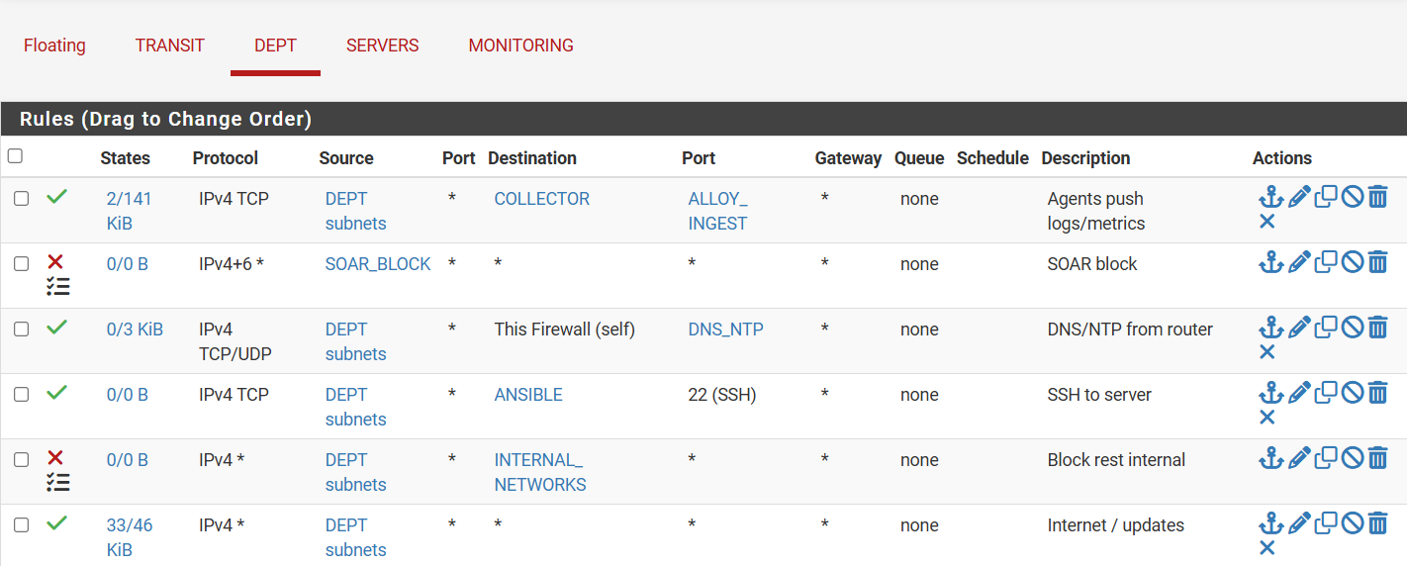
DEPT interface (department workstations)
- Agents push logs/metrics: the Alloy agents on the workstations send logs and metrics to the collector (ALLOY_INGEST ports).
- SOAR block: any address in the SOAR_BLOCK alias is blocked. The SOAR Lambda assigns Ips to this alias automatically.
- DNS/NTP from router: workstations use the router for name resolution and time.
- SSH to server: SSH (22) from the department to the Ansible server.
- Block rest internal: all other traffic to the internal networks is blocked.
- Internet / updates: so workstations can reach the internet.
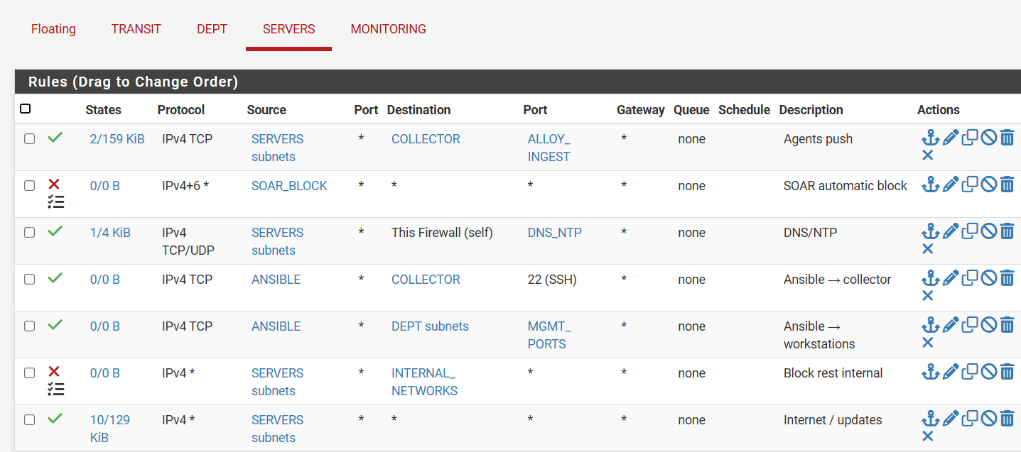
SERVERS interface (Ansible)
- Agents push: server agents send logs and metrics to the collector.
- SOAR automatic block: same SOAR_BLOCK alias as on DEPT.
- DNS/NTP: name resolution and time from the router.
- Ansible -> collector / Ansible -> workstations: Ansible may reach the collector over SSH and the workstations on the management ports (MGMT_PORTS) to configure them.
- Block rest internal / Internet / updates: same as on DEPT.
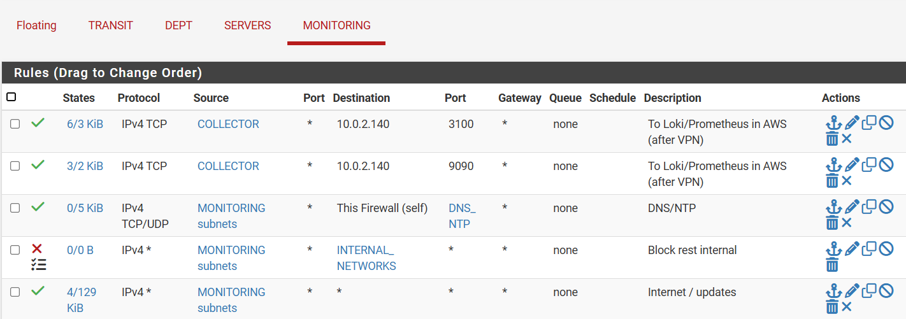
MONITORING interface (Collector)
- To Loki (3100) and Prometheus (9090): only the collector can send logs and metrics to the monitoring server in AWS (10.0.2.140) over the VPN.
- DNS/NTP, Block rest internal, Internet / updates: same as the other networks.

Security Groups
In AWS every tier has its own security group. A security group is a stateful firewall on the instance itself, I like to imagine it a bit like a bubble that is around an object and you need to go through the bubble walls first before you get to touch the object. I used Security Groups instead of a Firewall, because of the costs it comes with, so the cheaper option was the go-to. Together with the pfSense rules this makes two layers of filtering in total.
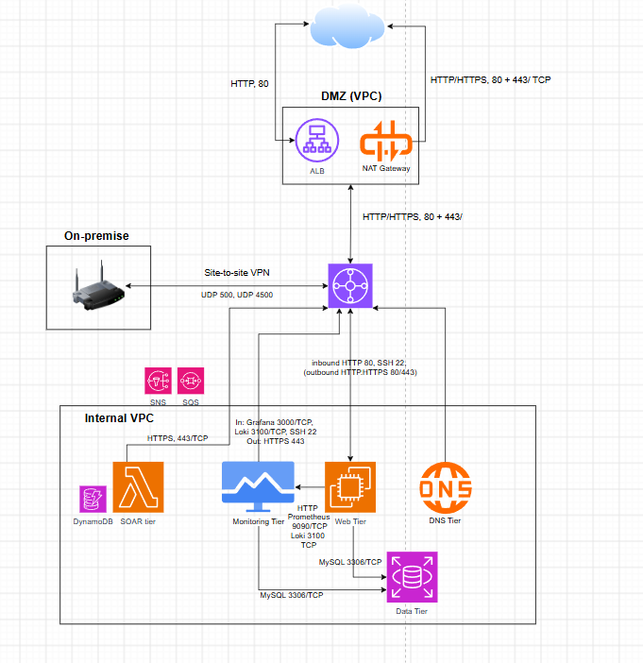
- ALB (DMZ VPC): accepts HTTP 80 from the internet and can only forward HTTP 80 to the web tier subnets. The ALB is the only part of the environment that is open to the public.
- Web tier: accepts HTTP 80 only from the ALB subnets, so users can never reach a web server directly. On-premise (192.168.0.0/18) may ping the web servers for testing. For outbound it can use HTTP/HTTPS 80/443 to go through the NAT Gateway for updates.
- Data tier (MySQL RDS): accepts MySQL 3306 only from the web tier security group and from the monitoring subnet. It has no outbound rules, because a database never needs to start a connection itself.
- Monitoring tier: accepts Loki 3100 and Prometheus 9090 only from the on-premise collector, and Grafana 3000 only from the admin PC, both through the VPN. Outbound HTTP/HTTPS is allowed for updates and to send alerts to SNS.
- SOAR tier (Lambda): has no inbound rules at all, because nothing needs to connect to the Lambda. Outbound it only uses HTTPS 443, to reach the pfSense API over the VPN and AWS services such as SQS, DynamoDB and CloudWatch.
- DNS tier: a Route 53 private hosted zone. It is a managed AWS service and needs no security group of its own.
- Site-to-site VPN: the IPsec tunnel between Router 1 and AWS uses UDP 500 (IKE) and UDP 4500 (NAT-T).

SOAR
The SOAR (Security Orchestration, Automation and Response) scenario, which I have for now detects an SSH brute-force attack on-premise and blocks the attacker on the pfSense firewall automatically, without anyone having to act.
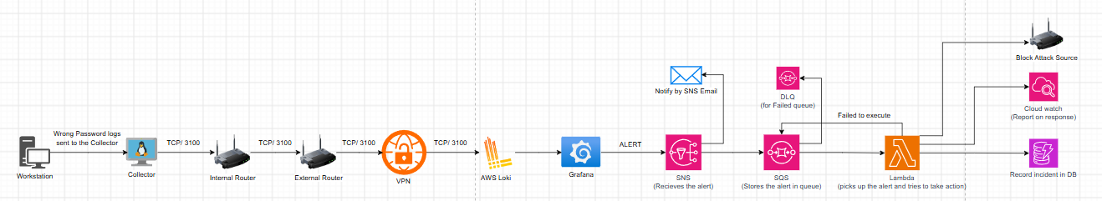
Overview. A workstation produces failed SSH login logs. These go to the collector, then through Router 2, Router 1 and the VPN to Loki in AWS. Grafana checks the logs and, when the attack is detected based on a pattern (> 5 failed ssh attempts), sends an alert to SNS. SNS emails the administrator and places the alert in an SQS queue through a subscription. A Lambda function picks it up, blocks the attack source on the router, reports to CloudWatch and records the incident in DynamoDB. Alerts that keep failing go to a dead-letter queue (DLQ).

Part 1: the log is created and collected
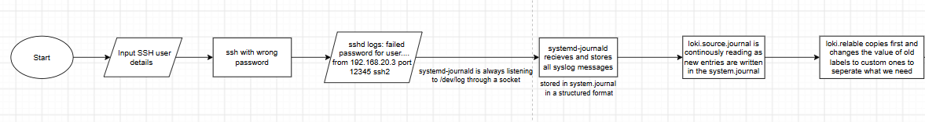
Someone enters SSH user details with a wrong password. sshd writes a log line such as "Failed password for user … from 192.168.20.3 port 12345 ssh2". systemd-journald is always listening on /dev/log through a socket so it just receives the message and stores it in the system journal in a structured format. The Alloy agent (loki.source.journal) keeps reading new entries from the journal on a small interval so then loki.relabel copies the old labels into custom labels, so that only the fields we need are kept.

Part 2: from on-premise to Loki in AWS
On a short timer loop, loki.write.collector sends the logs over HTTP on port 3100 to the collector. The collector is also an Alloy instance, but acts more like a gateway for the logs. loki.source.api listens on port 3100 for the agents and labels the logs "onprem" in the collector. loki.write.aws then forwards them through the VPN to Loki in AWS, which is also listening on 3100. Loki stores the logs, and Grafana queries them in JSON format.

Part 3: Grafana raises the alert
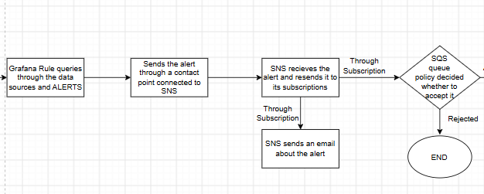
A Grafana alert rule queries Loki. If one source IP has more than 5 failed SSH logins in 10 minutes, the alert fires. The alerts are grouped per source IP. Grafana sends the alert through a contact point to the SNS topic. SNS forwards it to each of its subscriptions, so an email goes to my personal email, and a copy goes to the SQS queue. The SQS queue policy only accepts messages from this SNS topic, and anything else is rejected.

Part 4: the queue and the Lambda
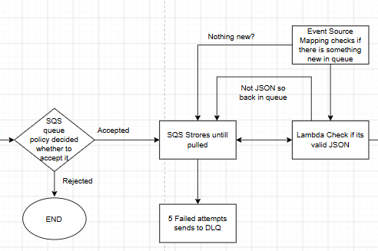
SQS stores the message until it is picked up. The Lambda event source mapping keeps checking the queue for new messages. The Lambda first checks that the message is valid JSON. If it fails, the message goes back into the queue and is tried again. After 5 failed attempts the message is moved to the dead-letter queue (DLQ), so it is not lost and can be investigated.

Part 5: blocking the attacker
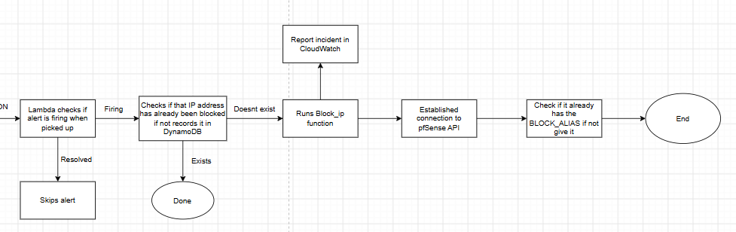
The Lambda checks whether the alert is still firing. A "resolved" alert is skipped. Next it checks DynamoDB to see whether this IP address has already been blocked. If it has, nothing else happens, which stops the same IP from being handled twice. If it has not, the incident is recorded in DynamoDB and the block_ip function runs. The incident is reported in CloudWatch. The Lambda connects to the pfSense REST API on Router 2 over the VPN, checks whether the IP is already in the SOAR_BLOCK alias and adds it if not. Because the SOAR_BLOCK rule is already on the DEPT and SERVERS interfaces, the attacker is blocked straight away. Important addresses such as the TRANSIT network and the AWS VPC are on an allow-list, so the SOAR can never block them by mistake.

